**PE-0: Visual Studio / GitHub Integration for IGME-201**

1. Goto [www.github.com](http://www.github.com) and create a GitHub account if you do not have one already, or log in to your existing account. Select “Create repository”

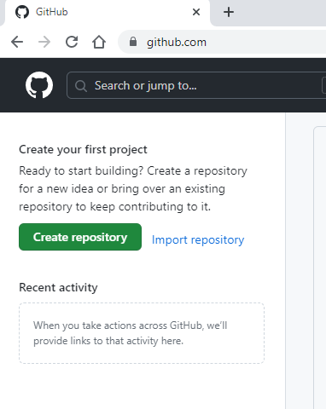

1. Name your repository “myIGME-201”
   1. Make it public
   2. Check the “Add a README file” checkbox (VisualStudio’s git functions may fail if you do not have at least one file in your repo)
   3. Select the VisualStudio gitignore template from the dropdown (this will prevent git from adding unnecessary binary files to your repo)

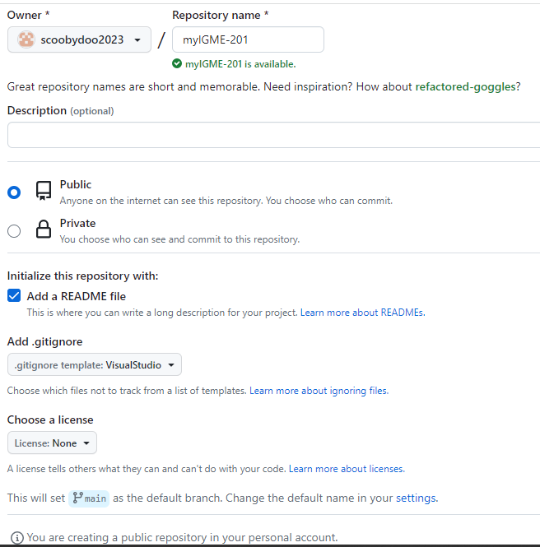

1. And you will see your new repo

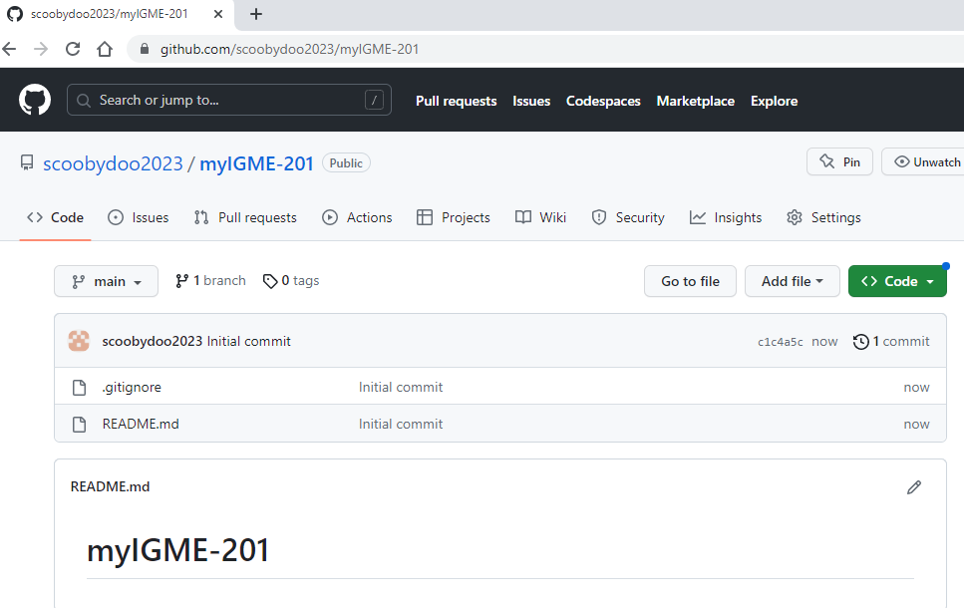

1. Start Visual Studio 2022 and click the “Continue without code” link to the right

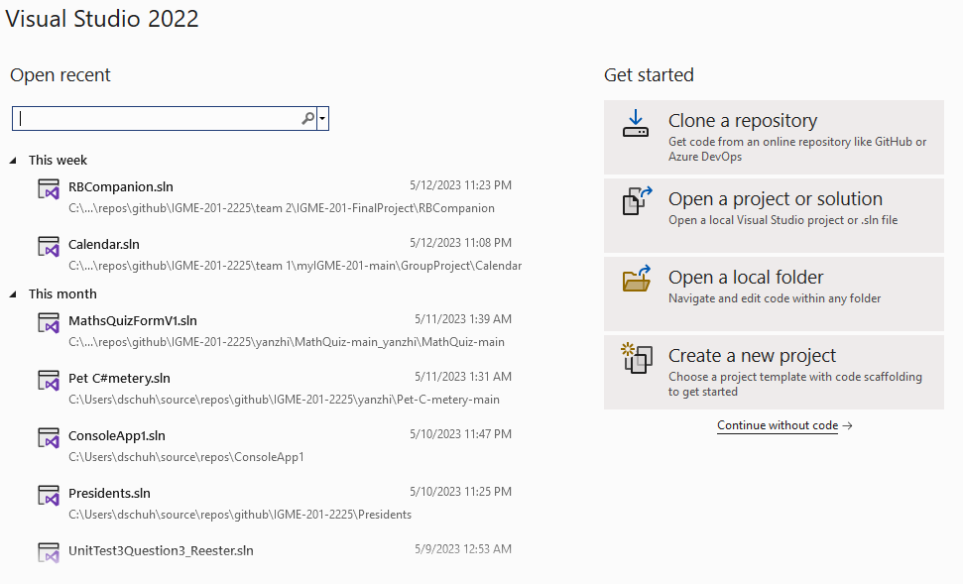

1. Your repo is on the GitHub.com cloud server. Now we want to download or “clone” your repo onto your computer so that you can add, edit or remove files from your repo. This will create a local copy of your repo, which will track changes as compared to the cloud version of your repo.

At the main Visual Studio menu, select Git/Clone…

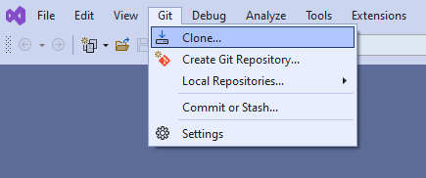

1. The Clone dialog window will display. Click the GitHub icon under “Browse a repository”. This initiates the connection between your Visual Studio session and GitHub.com

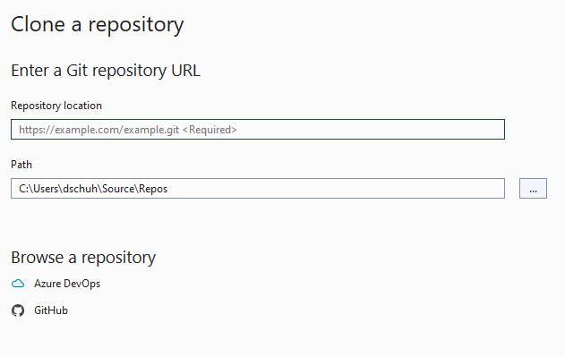

1. Click the combobox dropdown control and select GitHub account under “Add an account:”

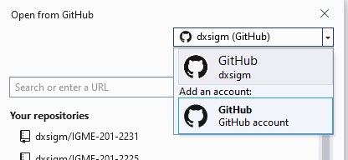

1. This will launch the GitHub.com website where you should log in with the same user as step #1.

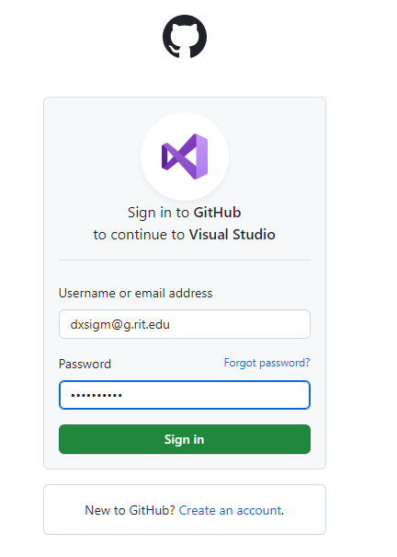

1. After successful login, an authorization page will display

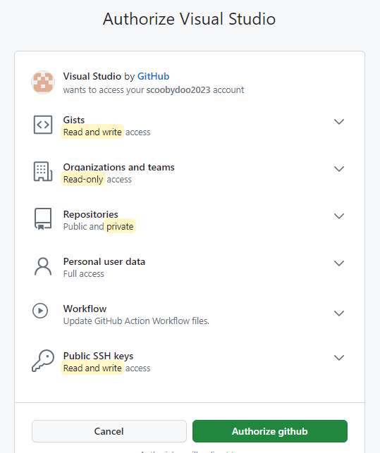

1. Then a success page will display after you click “Authorize github”

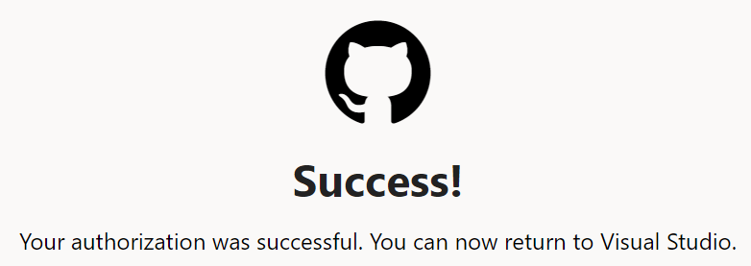

1. Return to Visual Studio, click your myIGME-201 repo under “Your repositories”, then click “Browse…” to select the local folder to download the repo to.

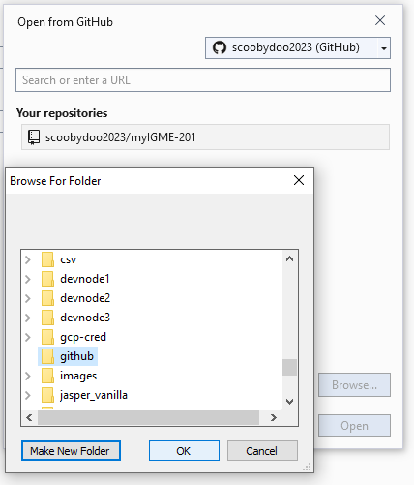

1. I selected c:\github and VS automatically added myIGME-201 to the path as seen in “Local path”. Click “Clone”

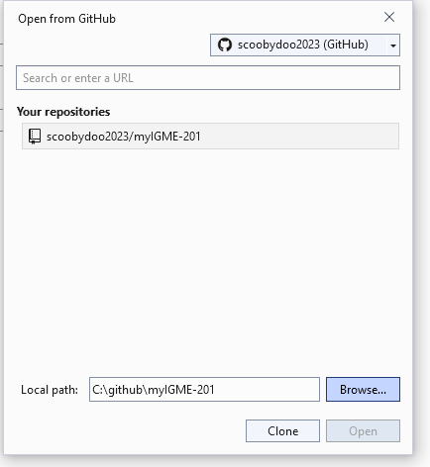

1. Now your repo has been downloaded to your computer and will be tracked for differences compared to the cloud repo. Let’s create a new project to check-in and push to our repo in the cloud.

Select File/New/Project…

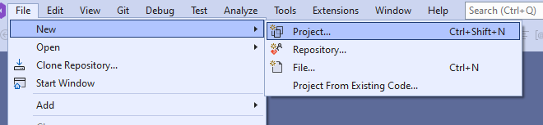

1. For all of the console applications you will create, be sure to select “Console App (.NET Framework)” as the project template. You can use the search controls to search for “C#”, “Windows” and “Console” as seen below. DO NOT select the first “Console App” template. We must use the .NET Framework to generate compatible code across all of the projects we will be creating this semester.

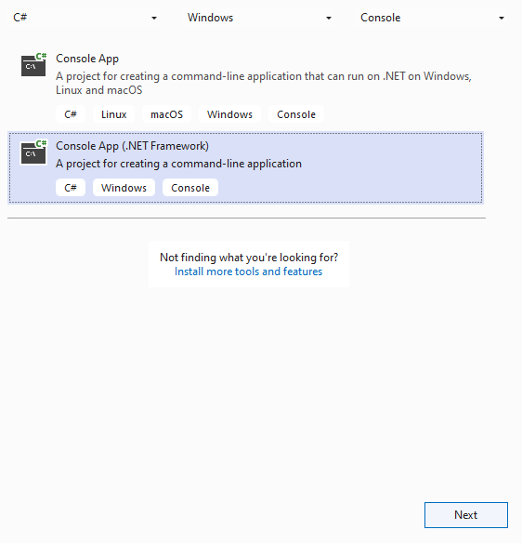

1. Call this project “GithubFirstCommit” and be sure to set the “Location” as the cloned repo folder that you selected in step #12.

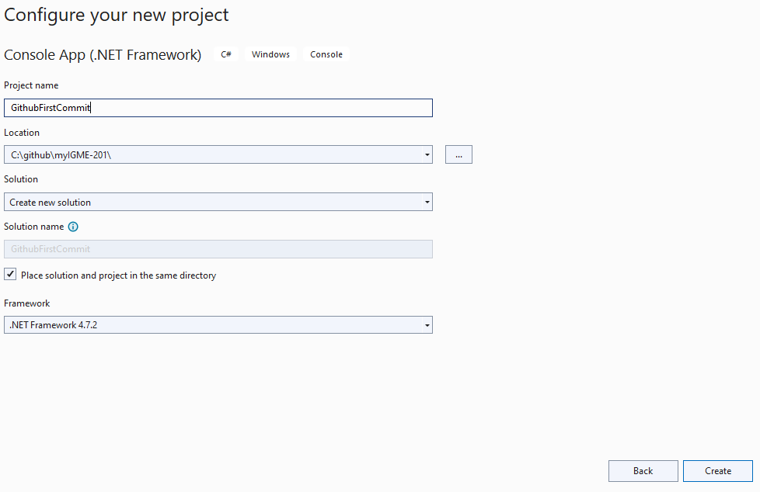

1. I recommend setting up your Visual Studio IDE with the Solution Explorer and Git Changes panels tab-docked to the right of your source windows. Select View/Solution Explorer and dock it to the right. Then Select View/Git Changes and tab-dock that next to the Solution Explorer panel.

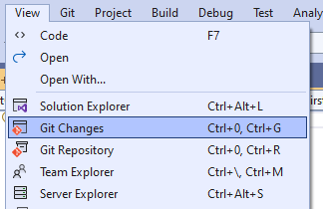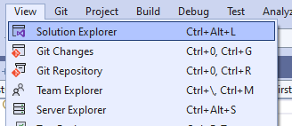

1. Your IDE should look something like this

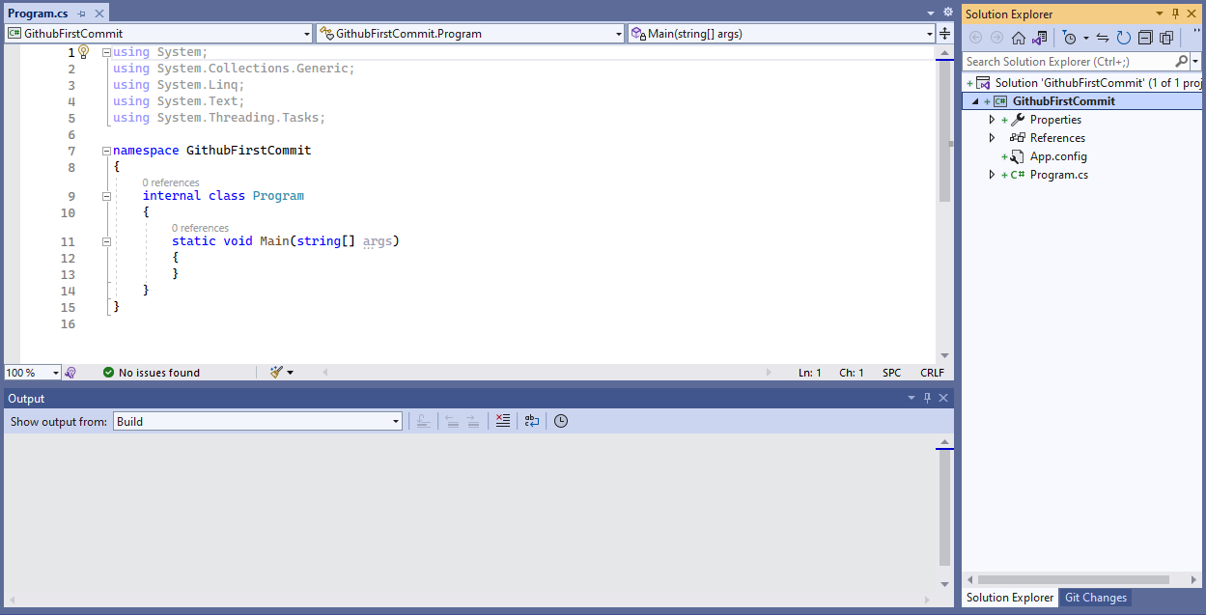

1. Click the “Git Changes” tab to see the files that have changed in your local copy of the repo. As you work on your projects, you will commit and push your changes to your cloud-based repo to save and keep history of your progress.

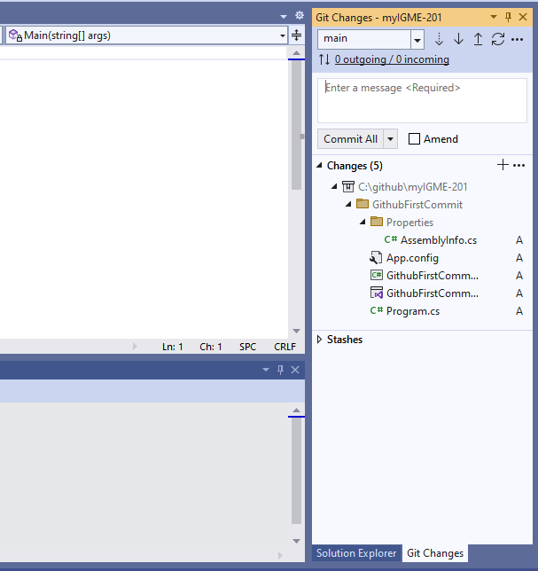

1. Enter the required check-in message, and select “Commit All and Sync” from the combobox dropdown control. This will pull the latest code from your cloud repo, commit the changes to your local repo, and push your changes to your cloud repo.

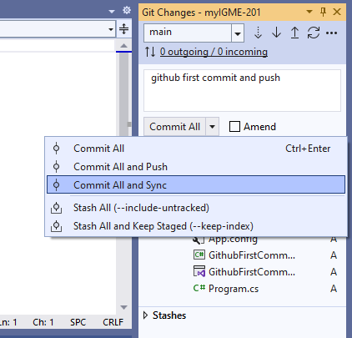

1. You will be prompted to sign in to your cloud repo. Click “Sign in with your browser”

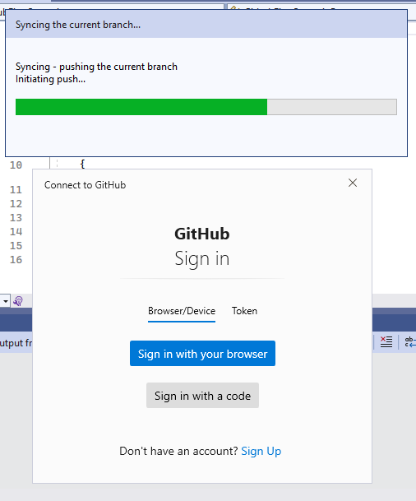

1. Then you need to “Authorize git-ecosystem”. I think this only needs to be done once.

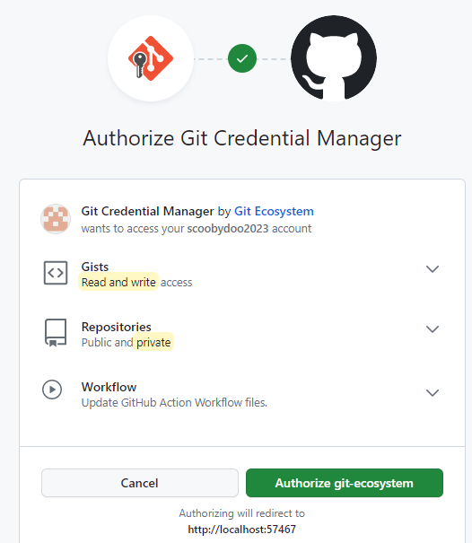

1. You will then see the message in the “Git changes” panel in VS 2022: “Successfully synchronized incoming and outgoing commits”

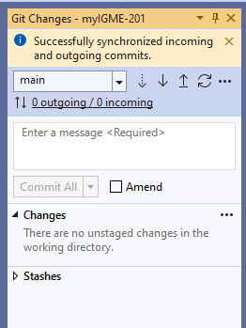

1. In GitHub, select the dropdown menu for your account and select “Your repositories”

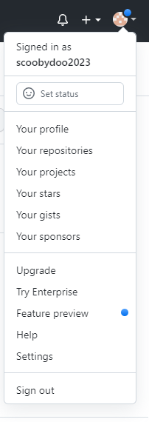

1. Select your myIGME-201 repo.

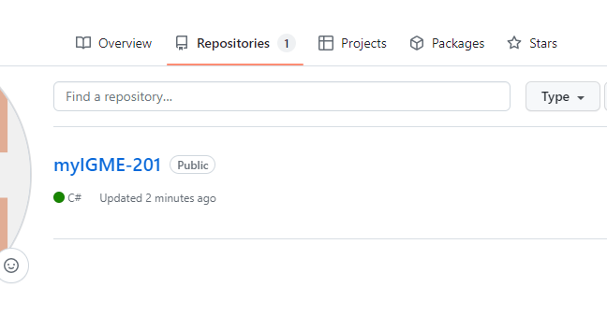

1. Select the new project you just checked in “GithubFirstCommit”

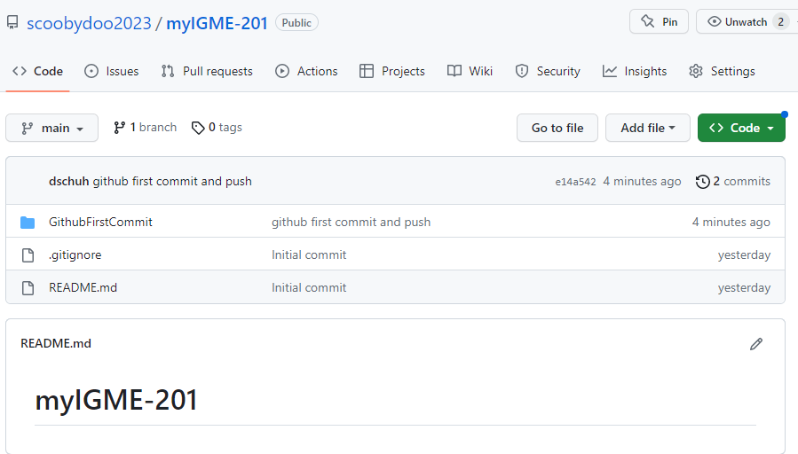

1. And you will see the source code you checked in this project.

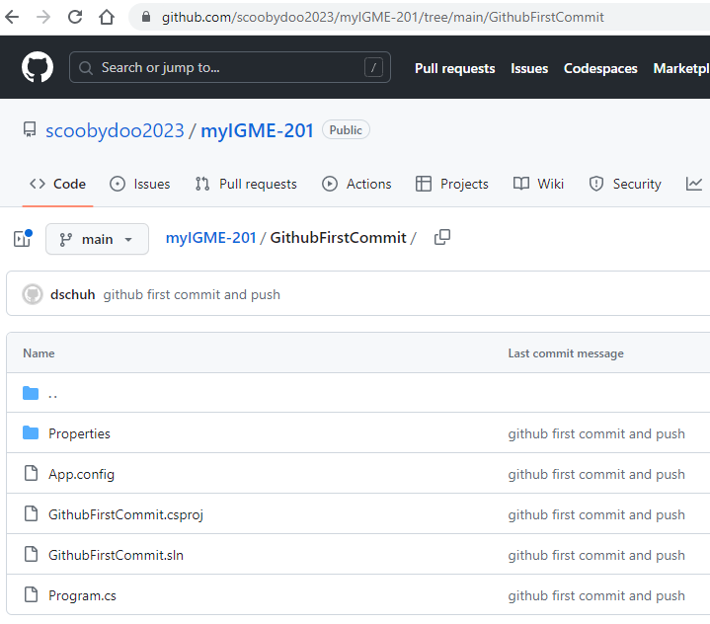

1. When you submit homeworks in myCourses, submit the address bar URL of the folder of the assignment, such as: <https://github.com/scoobydoo2023/myIGME-201/tree/main/GithubFirstCommit>
2. Submit that URL for this homework and for each new homework goto step #13 and repeat!
3. After each lecture, I will announce when the course GitHub repo is up-to-date, and I expect you to download the course GitHub repo to review the code written in class.

Goto <https://github.com/dxsigm/IGME-201-2231> and click the Green dropdown control and select “Download ZIP”

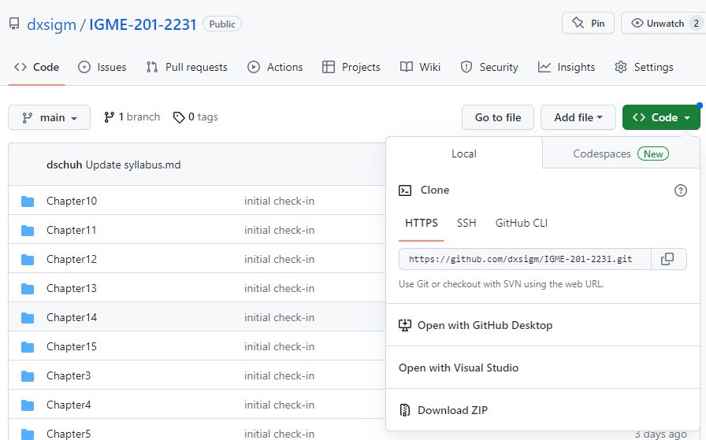

This will zip and download the repo to your Downloads folder.

Click the caret (^) and select open on the menu:

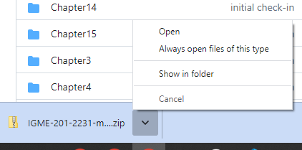

Right click the IGME-201-2231-main folder and select Copy:

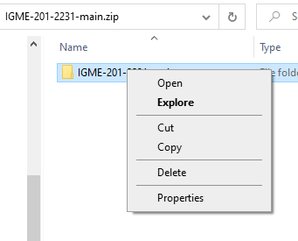

And paste it to the same folder where your myIGME-201 folder resides (c:\github in my example)

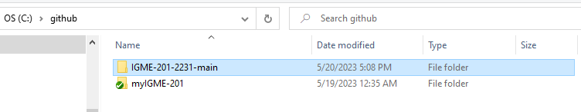

Browse to the current lecture and review the code:

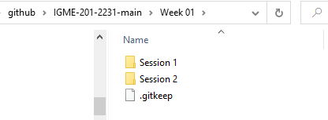

Repeat step #29 after every lecture.